|  |
| --- |
| *Insert Your Company Name and/or Logo Here* |

**REGULATORY REFORM (FIRE SAFETY) ORDER 2005**

**FIRE RISK ASSESSMENT TEMPLATE GUIDANCE**

**(Version 4)**

This guidance document has been produced to assist the Responsible Person to complete a Fire Risk Assessment using the template provided by Dorset & Wiltshire Fire and Rescue Service.

The template may not be suitable for use in some larger, high risk or complex premises. Dorset & Wiltshire Fire and Rescue Service accept no responsibility for any modifications or amendments made to the template structure or any user content added. Use of the template will not automatically guarantee the completed risk assessment will be regarded as “suitable and sufficient” therefore it should only be completed by a person with the necessary training, skills or ability to do so.

To help you undertake a suitable and sufficient risk assessment for your premises, the Government has provided a suite of premises use specific **Fire Safety Risk Assessment Guides**. The guides provide additional information to assist you in completing your fire risk assessment in part one and further information on specific requirements in part two. The guides are free to download from [www.gov.uk](https://www.gov.uk/government/collections/fire-safety-law-and-guidance-documents-for-business). You may need to refer to one or more guides if your premises include more than one premises use group.

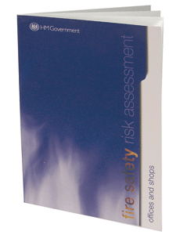

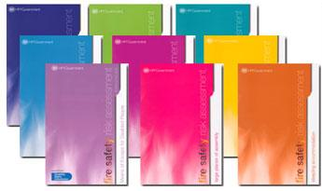

**Building Safety Act 2022: Section 156**

On 1 October 2023, **important** changes to fire safety legislation commence which may affect you.

If you are the responsible person of a small business, small block of flats or a holiday let, you may have previously been exempt from the requirement to have a written fire risk assessment. From 1 October 2023, you will need to have a full, written record of your fire risk assessment regardless of the size or use of your building.

If you are the responsible person for a building containing two or more domestic premises (i.e. flats) there is already a requirement to provide information to residents on the importance of fire doors and what to do in the event of a fire. From 1 October 2023, you will need to provide all residents with information on the risks identified in your fire risk assessment as well as the fire safety measures in place to keep them safe.

If you are the responsible person for a building where there are multiple responsible persons, for example, a building which is occupied by multiple businesses, or buildings where the occupier leases/rents the premises from a landlord, you will need to share and keep a record of information on the extent of your fire safety responsibilities. For example, you should establish, and document, who is responsible for maintaining fire safety measures such as a fire alarm system. There are increased requirements for cooperation and coordination between responsible persons. This includes multi-occupied premises or buildings where the occupier and building owner are different entities.

For further information on the changes to legislation, please visit [Fire safety responsibilities under Section 156 of the Building Safety Act 2022](https://www.gov.uk/government/publications/check-your-fire-safety-responsibilities-under-section-156-of-the-building-safety-act-2022/fire-safety-responsibilities-under-section-156-of-the-building-safety-act-2022)

**Regulatory Reform (Fire Safety) Order 2005**



The Regulatory Reform (Fire Safety) Order 2005 became law in October 2006 and introduced significant change to workplace fire safety responsibilities. As well as simplifying the legislative regime by bringing all fire safety legislation together into one Order, it introduced the need for employers, building owners and occupiers as 'responsible persons' to carry out, implement and maintain a fire safety risk assessment.  
  
All non-domestic premises, including the common or shared parts of blocks of flats or houses in multiple occupation are covered by the Order, and may be inspected by their local Fire and Rescue Authority.

Under the Order, Fire and Rescue Authorities have a statutory duty to ensure compliance and enforce the requirements where necessary.

**What are the main requirements of the Order?**

The responsible person is required to:

* Carry out a fire risk assessment identifying the risks and hazards.
* Consider who may be especially at risk.
* Eliminate or reduce the risk from fire as far as is reasonably practical and provide general fire precautions to deal with any residual risk.
* Take additional measures to ensure fire safety where flammable or explosive materials are used or stored.
* Create a plan to deal with any emergency and document your findings.
* Review the findings as necessary.

In carrying out a fire risk assessment the responsible person may decide that given the nature of the premises or the people involved, they may need to appoint one or more competent persons to assist them. The level of necessary competence is not prescribed in the Order. It recognises that the extent of competency will vary according to the nature and complexity of the premises involved.

The Fire Safety Order requires that you give effect to arrangements for the planning, organisation, control, monitoring and review of the preventive and protective measures. These are the measures that have been identified as a consequence of a risk assessment as the general fire precautions you need to take to comply with the Fire Safety Order.

**Where does it apply?**

The Order applies to virtually all premises and covers nearly every type of building, structure and open space. For example:

* Offices and shops
* Premises that provide care
* Community halls
* The common areas of houses in multiple occupation including common fire warning systems etc.
* Pubs, clubs and restaurants
* Schools
* Tents and marquees
* Hotels, B&Bs, guest houses, hostels and self-catering accommodation
* Factories and warehouses
* Stables

**What does this mean for me?**

The Fire Safety Order puts greater emphasis on fire prevention in all non-domestic premises, including the voluntary sector and self-employed people with premises separate from their homes.

Responsibility for complying with the Fire Safety Order will rest with the 'responsible person'. In a workplace, this is the normally the employer or any other person who may have control of any part of the premises (e.g. the occupier or owner). If there is more than one responsible person in any type of premises, they must take all reasonable steps to consult with one another regarding matters of fire safety.

If you are the responsible person you will have to carry out a fire risk assessment which must focus on the safety in case of fire of all 'relevant persons'. It should pay particular attention to those at special risk, such as the disabled and those with special needs, and must include consideration of any dangerous substance likely to be on the premises. Your fire risk assessment will help you identify risks that can be removed or reduced and to decide the nature and extent of the general fire precautions you need to take to protect people against the fire risks that remain.

The fire risk assessment should consider dangerous substances that are used or stored in your premises, only to the extent necessary to determine the adequacy of the *general fire precautions (as defined in Article 4 of the Fire Safety Order*) and to advise you accordingly. If dangerous substances are used or stored in your premises, you should ensure that a risk assessment of the relevant work activities has been carried out to enable you to comply with the Dangerous Substances and Explosive Atmospheres Regulations 2002. This fire risk assessment must consider special, technical or organizational measures that are required to be taken or observed in connection with the use or storage of any dangerous substance.

For further information on all the changes to legislation and what you need to do to comply, the Government has published guidance which is available on the Government's website.

**Fire Safety (England) Regulations 2022**

The regulations came into force on 23 January 2023 and introduce new requirements for multi-occupied residential buildings, and different regulations apply depending on a building’s height.

Video introducing the [Building Safety Act 2022: Section 156 (nationalfirechiefs.org.uk)](https://www.nationalfirechiefs.org.uk/Building-Safety-Act-2022-Section-156)

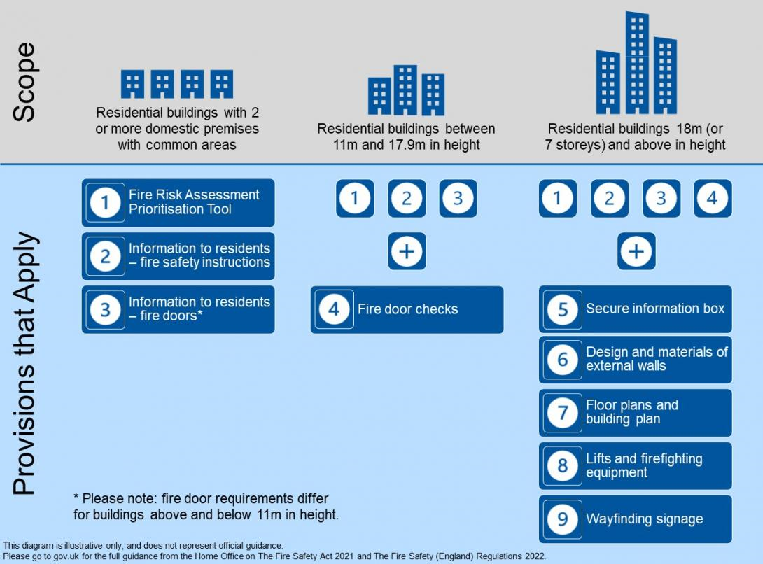

Fire Safety (England) Regulations 2022 - GOV.UK (www.gov.uk)

[Dorset & Wiltshire Fire Service | Fire Safety (England) Regulations 2022 (dwfire.org.uk)](https://www.dwfire.org.uk/safer-housing/multi-occupied-residential-buildings/residential-buildings-18m-and-higher/fire-safety-england-regulations-2022/)

<https://www.dwfire.org.uk/safer-housing/multi-occupied-residential-buildings/residential-buildings-18m-and-higher/fire-safety-england-regulations-2022/>

**USING THE FIRE RISK ASSESSMENT TEMPLATE**

The Fire Risk Assessment Template is divided into sections as follows:

* Front page
* General Information
* Identified Fire Hazards and Primary Control Measures
* Arrangements for Evacuation
* Provision of Elements of Fire Safety as Secondary Control Measures
* Management of Fire Safety
* Remedy Action Plan

The Responsible Person must ensure that each section is fully completed with additional details included where necessary.

The location of any important written information, such as:

* General Evacuation Plans
* Personal Emergency Evacuation Plans
* Personal Staff Training Records
* Testing and Maintenance Records for alarms/lights etc, should be contained within the Fire Risk Assessment. (Logbook)

**Front page**

This section gives information as to who is the designated “Responsible Person” for the premises under the Regulatory Reform (Fire Safety) Order 2005 and information regarding who carried out the assessment, the date of completion and any subsequent reviews.

**General Information**

This section gives basic information about the premises itself (Number of floors, size, construction and usage).

Include details and numbers of occupants especially at risk from fire (i.e., sleeping, disabled persons to include hearing impairment, learning disability or mental health, lone workers, young persons, elderly, infirm etc).

The fire safety measures required within your premises should be entirely focused on the needs of people who will use it.

**Identified Fire Hazards and Primary Control Measures**

It is important that each section is **fully completed**, including the identified hazards, existing control measures, and if any additional control measures are subsequently required. The Fire Safety Risk Assessment guides will assist in the identification of most generic hazards and control measures which may be relevant to your premises. Example:

|  |  |  |
| --- | --- | --- |
| **ELECTRICAL SOURCES OF IGNITION** | | |
|  | | |
| Fixed installation periodically inspected and tested? (Commercial - every 5 years) | | **NO** |
| Portable appliance testing carried out on a risk assessed basis? | | **YES** |
| Suitable policy in place regarding the use of personal electrical appliances? | | **YES** |
| Suitable limitation and management of trailing leads and adaptors? | | **YES** |
|  | | |
| Identified Hazards | Existing Control Measures | Additional Control Measures Required |
| Photocopiers  IT Equipment  Desk Fans  Desk Lamps  Kettle  Microwave  Vacuum Cleaner | All items over 12 months PAT tested annually  Staff prohibited from using personal equipment  Maintenance Team inspect all leads, adaptors and plugs periodically  Staff instructed to visually check leads and cables periodically | Fixed installations may require inspecting |
| **Deficiencies and Comments:**  Unable to determine when fixed installations were last tested by a competent person.  **Deficiencies, additional control measures and recommendations should be copied into the Remedy Action Plan at the end of the Fire Risk Assessment, and the appropriate action taken.** | | |

**Arrangements for Evacuation**

The determined strategy of evacuation within your premises is paramount to the safety of all occupants. Any evacuation strategy must be carried out without fire service intervention.

If Personal Emergency Evacuation Plans (PEEPS) are in use, then details of these should also be made reference to.

**Means of Escape for Disabled People (Supplementary Guide)**

The Government Guidance documents also include a supplementary guide providing further information on fire safety provisions for disabled persons. This can be downloaded here: [Means of Escape for Disabled Persons](https://www.gov.uk/government/publications/fire-safety-risk-assessment-means-of-escape-for-disabled-people).

**Provision of Elements of Fire Safety - Secondary Control Measures**

**Primary** Control Measures are taken to prevent, as far as reasonably practical, a fire from starting.

**Secondary** Control Measures are taken to ensure that if a fire does start; all occupants are alerted and evacuated quickly and safely as possible.

It is therefore important that you have suitable:

Fire warning and detection;

Means of escape (design of, travel distances, number of exits, etc)

Compartmentation (fire resisting walls, glazing and doors);

Emergency lighting;

Signage;

Fire extinguishers.

The fire safety guidance books provide more detailed information as to the minimum required standards relevant to your type of premises.

Fire warning and detection systems are installed to British Standard 5839. Some examples of grading are as follows:

* Type L5: Life safety generally when specific fire engineering solutions or where Public Indemnity insurance is required.
* Type L4: Life safety system, same as a manual system plus smoke detection on escape route.
* Type L3: Life safety system, same as a manual system plus smoke detection on escape route and heat or smoke detection in adjacent rooms.
* Type L2: Life safety system, same as L3 but additional detection provided in fire hazard/risk of ignition areas (i.e. kitchens, boiler rooms, sleeping areas and other specified areas.)
* Type L1: Life safety system, detection provided in all areas, including voids and unused spaces.

Fire Inspecting Officers may require to see relevant certificates for fire alarm installations such as:

* Installation Certificate
* Commissioning Certificate
* Alteration Certificate (if appropriate)
* Test Certificate

**Management of Fire Safety**

This section determines responsibility for different elements of fire safety within the premises.

It also should include information regarding initial and remedial fire safety training provision for members of staff and information provided to external contractors, testing and maintenance regimes for all fire safety measures and subsequent recording requirements.

A logbook is a good way of providing evidence that testing and maintenance systems are in place and properly managed. Records of training may be kept in individual personal files although you may also consider providing a separate training record for key personnel with specific fire safety duties.

**Remedy Action Plan**

This section should be used to make a written record of any additional action/control measures identified when carrying out the initial or subsequent review of your Fire Risk Assessment (i.e. a ‘to do’ list).

Remedial action should be prioritised accordingly, and action completed within the timescales identified. Where it has not been possible to complete the action on schedule, the reason should be noted, and a new date set for completion.

Fire Inspecting Officers who visit your premises may refer to this section to determine whether any issues identified during the visit have previously been identified and whether an appropriate course of corrective action has been identified.

| **SIGNIFICANT FINDINGS – REMEDY ACTION PLAN** | | | | | |
| --- | --- | --- | --- | --- | --- |
| **No** | **Action to be Taken** | **Priority** | **Target Completion Date** | **Action by** | **Date Action Completed** |
| 1 | Fixed installations require inspecting | LOW | 1 month | Maintenance |  |
| 2 |  |  |  |  |  |
| 3 |  |  |  |  |  |

**INTENTIONALLY BLANK**