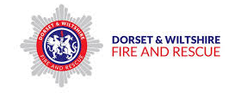
SDSA 360 VR - ACTION PLAN

SPEAK TO THE PEOPLE YOU LIVE WITH:
- What could you do if you need an alternative lift late at night?
- Who could you call?
- What if you didn’t have money for a taxi? – could there be an “emergency fund” pot at home for your return journey?
- Could you agree a safe phrase or word which you could text an adult at home? - In an emergency the adult receiving this message can phone you saying there is a problem and you have to be home - they can then offer to collect you.

RESEARCH LOCAL TRANSPORT:
- Do you know when the last train home is?
- Where’s your local bus stop?
- What time do the buses stop running?
- How much bus or train fare would you need?
- What other benefits are there to getting public transport?
- Programme a local taxi number into your phone so you always have it to hand?

FOLLOW US @dwfirerescue www.dwfire.org.uk

Have any ideas or feedback? We’d love to hear from you! Please contact our Road Safety Team: roadsafety@dwfire.org.uk
If you have been affected by any of the issues, help can be sought from:

