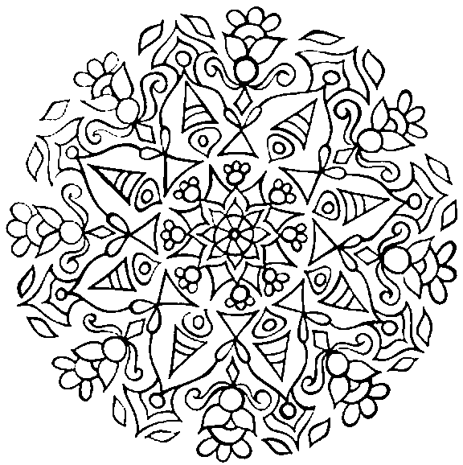

Find the underlined words in the wordsearch below

Diwali is a Hindu Festival celebrated in Autumn.

Diwali means 'rows of lighted lamps'.

Diwali is known as “The festival of light” .

During Diwali houses, shops and public places are decorated with small earthenware oil lamps called diyas .

Diwali is a time for

* a spring-clean of the home,
* wearing new clothes
* exchanging gifts (often sweets and dried fruits) and preparing festive meals
* decorating buildings with fancy lights.
* fireworks
* patterns are drawn on the floor. (information taken from bbc.co.uk/schools)

How to stay fire safe during Diwali:

Have working smoke alarms and escape plan. If there is a fire get out, stay out and call 999, ask for the firefighters.

Keep matches and lighters out of young children’s reach and never mess around with matches or lighters.

Take care with candles. Candles should be in proper candle holders and in a place where they will not fall over or anything fall onto them.

If clothes catch fire: stop, drop and roll.

Diwali

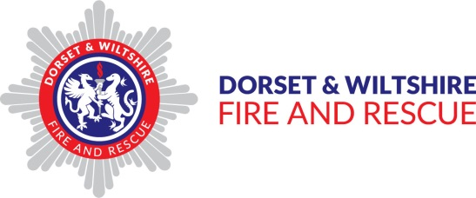

|  |  |  |  |  |  |  |  |  |  |  |  |  |
| --- | --- | --- | --- | --- | --- | --- | --- | --- | --- | --- | --- | --- |
| d | i | w | a | l | i | n | e | w | t | s | f | s |
| f | s | c | a | n | d | l | e | e | s | t | i | p |
| i | m | s | t | a | y | o | u | t | t | o | r | r |
| r | o | f | e | s | t | i | v | a | l | p | e | i |
| e | k | g | h | i | n | d | u | r | l | d | f | n |
| w | e | i | f | l | o | o | r | o | a | r | i | g |
| o | a | f | i | f | i | r | e | w | m | o | g | c |
| r | l | t | s | a | f | e | t | s | p | p | h | l |
| k | a | s | t | l | i | g | h | t | s | r | t | e |
| s | r | d | i | y | a | s | o | i | l | o | e | a |
| u | m | e | s | g | e | t | o | u | t | l | r | n |
| d | s | m | a | t | c | h | e | s | a | l | s | y |

Use the remaining letters to finish this sentence:

Test your smoke alarm every week; remember _ _ _ _ / _ _ / _ _ _ _ _ _ _

Diyas are oil lamps, often bright and colourful.

Colour in the one below, you could add your own patterns.



Picture from coloringkids.org

