Halloween

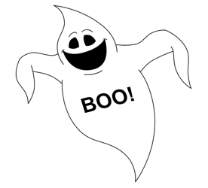

**Can you find the underlined words in the wordsearch?**

Halloween falls on the 31st October on the eve of All Hallows Day.

Many people celebrate Halloween by dressing up in scary costumes such as ghosts, witches, vampires, Egyptian mummies and other scary characters.

Often pumpkins are carved to show funny or scary faces or even scenes. A candle is placed inside which makes the face or scene glow.

If you have a pumpkin with a candle inside you need to be very careful, especially if you are in a costume. If clothes do catch fire you need to stop, drop and roll until the fire is out. Stop and stand still, drop to the ground, roll to put the flames out.

If someone gets burnt you need to cool, call and cover. Cool the burn with cold water for at least twenty minutes, call for help whilst you are doing this and cover the wound with cling film or a none fluffy dressing or cloth.



|  |  |  |  |  |  |  |  |  |  |  |  |  |
| --- | --- | --- | --- | --- | --- | --- | --- | --- | --- | --- | --- | --- |
| h | a | l | l | o | w | e | e | n | e | s | t | o |
| c | y | g | h | o | s | t | s | c | o | o | l | c |
| o | w | o | m | p | u | m | p | k | i | n | s | t |
| s | i | u | u | c | s | t | o | p | r | s | r | o |
| t | t | c | m | a | c | o | v | e | r | m | o | b |
| u | c | o | m | r | t | w | e | n | t | y | l | e |
| m | h | l | i | v | w | a | t | e | r | o | l | r |
| e | e | d | e | e | d | r | o | p | g | l | o | w |
| s | s | k | s | d | e | c | a | n | d | l | e | a |
| e | g | y | p | t | i | a | n | l | c | a | l | l |
| v | a | m | p | i | r | e | s | s | c | a | r | y |
| d | r | e | s | s | i | n | g | u | p | a | r | m |

Use the remaining letters to finish this sentence:

T _ _ _ / _ _ _ _ / _ _ _ _ _ / _ _ _ _ _



