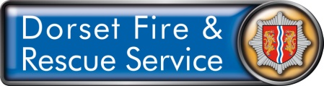

Volunteer Role
Community Volunteer Level 1 – Referral Generator

Why DFRS needs this role?
This role will help us to ensure the safety of people within their own homes by generating referrals to allow members of the team to complete Home Safety Visits.

Potential time commitment: For this role we would be looking for a minimum of 4 hours a week
Role Duration: 6 months (with the option to continue service)
Location: Home based

Responsibilities
- To generate referrals for Home Safety Visits
- To work alongside Dorset Fire and Rescue staff at local events
- Assist with the planning and setting up of displays at events
- To give general safety advice

Measures of success
- A target number of referrals will be issued to each station ground team or local area

Training & Support
- Training to fulfil your role will be provided
- DFRS will provide opportunities for personal development within your role

What will the role give you?
- Join a motivated team
- Learn new skills
- Meet new people
- Improve self confidence
- Support your local community
- Enhance your CV

Person Specification
Minimum Level Required | Required | Desirable
Computer literacy
Excellent Interpersonal Skills
Team Player

