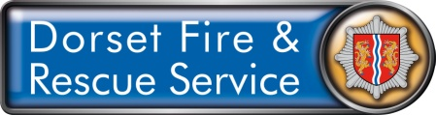
Volunteer Equipment List

Item | Size | Date Received | Comments
Trousers
Shirt/Blouse
Shoes
Socks
Blouson
Liner
Belt
T-shirt
Epaulettes (for blouson)
Sliders (for shirt/blouse)
ID card
Station Key Fob
Name badge
Summer hat
Winter hat

I agreed that I have received the above; these items remain the property of DFRS whilst I am volunteering with them, on completion of my volunteering I will return these items to my station for the attention of the Volunteer Coordinator.
Failure to return these items may result in a financial recompense being sought.

Community Volunteer name

Community Volunteer signature

Date

